Chapter 06.04

Nonlinear Models for Regression-More Examples

Chemical Engineering

Example 1
Below is given the FT-IR (Fourier Transform Infra Red) data of a 1:1 (by weight) mixture of ethylene carbonate (EC) and dimethyl carbonate (DMC). Absorbance is given as a function of wavenumber, m.
Table 1 Absorbance as a function of wavenumber.
Wavenumber,  () | Absorbance,  (arbitrary unit)
804.184 | 0.1591
827.326 | 0.0439
846.611 | 0.0050
869.753 | 0.0073
889.038 | 0.0448
892.895 | 0.0649
900.609 | 0.1204

Regress the above data to a second order polynomial
Find the absorbance at

Solution
Table 2 shows the summations needed for the calculations of the constants of the regression model.

Table 2 Summations for calculating constants of model.
 | Wavenumber,  () | Absorbance,  (arbitrary unit)
1 | 804.18 | 0.1591 | 6.4671 | 5.2008 | 4.1824 | 127.95 | 1.0289
2 | 827.33 | 0.0439 | 6.8447 | 5.6628 | 4.6849 | 36.319 | 3.0048
3 | 846.61 | 0.0050 | 7.1675 | 6.0681 | 5.1373 | 4.233 | 3.583
4 | 869.75 | 0.0073 | 7.5647 | 6.5794 | 5.7225 | 6.349 | 5.522
5 | 889.04 | 0.0448 | 7.9039 | 7.0269 | 6.2471 | 39.828 | 3.5409
6 | 892.90 | 0.0649 | 7.9726 | 7.1187 | 6.3563 | 57.948 | 5.1742
7 | 900.61 | 0.1204 | 8.1110 | 7.3048 | 6.5787 | 108.43 | 9.7655
 | 6030.4 | 0.4454 | 5.2031 | 4.4961 | 3.8909 | 381.06 | 3.2685

is the quadratic relationship between the absorbance and the wavenumber where the coefficients , , are found as follows
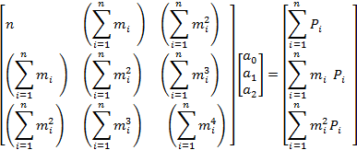
We have
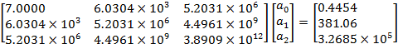

Solve the above system of simultaneous linear equations, we get
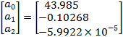

The polynomial regression model is
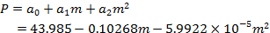

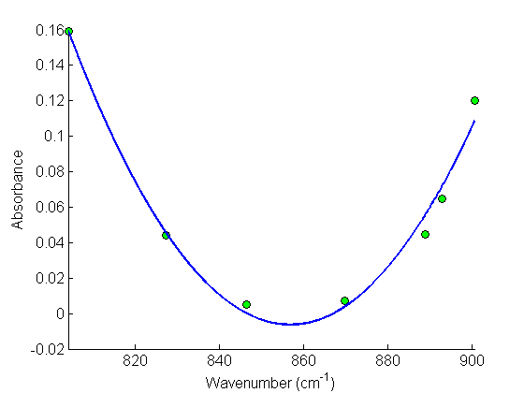
Figure 1 Second order polynomial regression model for absorbance as a function of
wavenumber.

To find where :
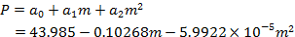

Example 2
The mechanism of polymer degradation reaction kinetics is suspected to follow Avrami or random nucleation reaction,
where , T is the absolute temperature (K), is the heating rate in K/min, is the frequency factor with units of rate constant, is the gas constant (8.314 kJ/kmol-K) and is the activation temperature. Given that , K/min and conversion, , at different temperatures are as given in table 3. Use the method of least squares to determine the values of and.

Table 3 Conversion at given different temperatures
Temp | 360 | 370 | 380 | 390 | 400 | 410 | 420 | 430 | 440
Conversion, | 0.1055 | 0.2010 | 0.3425 | 0.5146 | 0.6757 | 0.8026 | 0.8924 | 0.9544 | 1.00

Solution
To set-up the table, we must re-write equation
as
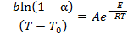

Taking natural log of both sides of the above equation, we obtain

so that the equation is in the form where
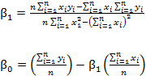

Table 4 Example on nonlinear exponential problem.
 |  | α
1 | 360 | 0.1055 | 2.7778 | −2.9476 | 7.7160 | −8.1877
2 | 370 | 0.2010 | 2.7027 | −2.6338 | 7.3046 | −7.1183
3 | 380 | 0.3425 | 2.6316 | −2.2862 | 6.9252 | −6.0163
4 | 390 | 0.5146 | 2.5641 | −1.9588 | 6.5746 | −5.0225
5 | 400 | 0.6757 | 2.5000 | −1.6936 | 6.2500 | −4.2341
6 | 410 | 0.8026 | 2.4390 | −1.4796 | 5.9488 | −3.6088
7 | 420 | 0.8924 | 2.3810 | −1.2932 | 5.6689 | −3.0791
8 | 430 | 0.9544 | 2.3256 | −1.0835 | 5.4083 | −2.5199
 |  |  | 2.0322 | −1.5376 | 5.1797 | −3.9787

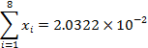
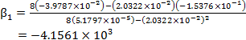

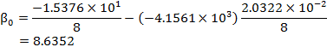
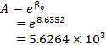
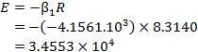
This gives the model as
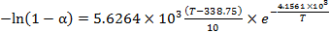
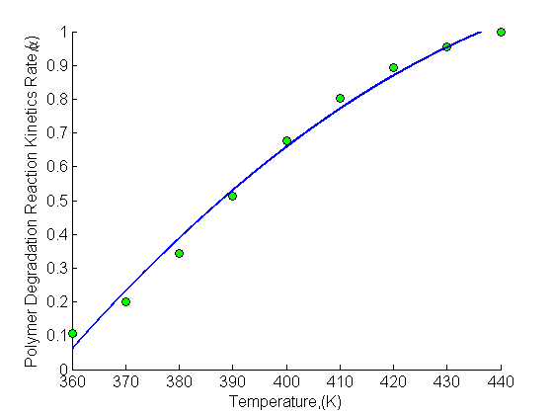
Figure 2 Polymer degradation reaction kinetics rate as a function of temperature.

Example 3
The progress of a homogeneous chemical reaction is followed and it is desired to evaluate the rate constant and the order of the reaction. The rate law expression for the reaction is known to follow the power function form
. (1)
Use the data provided in the table to obtain and.
Table 11 Chemical kinetics
 | 4 | 2.25 | 1.45 | 1.0 | 0.65 | 0.25 | 0.06
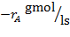 | 0.398 | 0.298 | 0.238 | 0.198 | 0.158 | 0.098 | 0.048

Solution
Taking natural log of both sides of Equation (1), we obtain
Let
from which (2)
(3)
We get
This is a linear relation between and , where
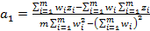

(4a,b)

Table 6 Kinetics rate law using power function.
1 | 4 | 0.398 | 1.3863 | −0.92130 | −1.2772 | 1.9218
2 | 2.25 | 0.298 | 0.8109 | −1.2107 | −0.9818 | 0.65761
3 | 1.45 | 0.238 | 0.3716 | −1.4355 | −0.5334 | 0.13806
4 | 1 | 0.198 | 0.0000 | −1.6195 | 0.0000 | 0.00000
5 | 0.65 | 0.158 | −0.4308 | −1.8452 | 0.7949 | 0.18557
6 | 0.25 | 0.098 | −1.3863 | −2.3228 | 3.2201 | 1.9218
7 | 0.06 | 0.048 | −2.8134 | −3.0366 | 8.5431 | 7.9153
 |  |  | −2.0617 | −12.391 | 9.7657 | 12.7401

From Equation (4a, b)
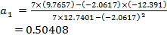

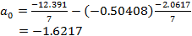
From Equations (2) and (3), we obtain
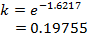

Finally, the model of progress of that chemical reaction is

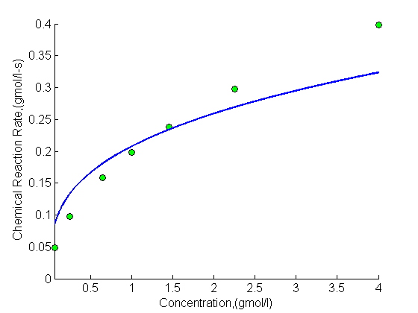
Figure 3 Kinetic chemical reaction rate as a function of concentration.

