
http://numericalmethods.eng.usf.edu/experiments
Loading the Truss

Background: The motivation behind the experiment is to show the application of simultaneous linear equations. We are loading a truss made of aluminum as shown in Figure 1. Four strain gages are attached to four of the members of the truss. You will choose a strain gage of your choice and compare the experimental result with the theoretical result.
Knowing the axial force in a member, the normal strain in the member is
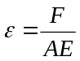 (1)
where
F = force in member, N
A = Cross-sectional area of member, m²
E = Young’s modulus of member, Pa

What you will do in the lab: You will choose one of the strain gages and use the P-3500 strain indicator to measure the strain. The instructions to set up the strain gage are given on the P3500 box. You will apply the load at the center of the truss as shown and record the strain. You will make the needed size measurements of the truss using a vernier caliper and scale, so that you can solve the problem posed below at home.

Exercises to do (50 points):
First, follow the sample project guidelines.
Use MATLAB to solve problems (5 thru 7). Use comments, display commands and fprintf statements, and sensible variable names to explain your work. Staple all the work in the following sequence. Use USCS system of units throughout.
- Signed typed affidavit sheet.
- Handwritten on engineering paper: Draw the sketch of the truss and name the members.
- Handwritten on engineering paper: Show the unknown member forces and reactions for each joint. Name the unknown forces and reactions so that they correspond to what you use as variable names in the MATLAB program. The unknowns are the reactions at the pinned and roller ends, and the forces in the members.
- Handwritten on engineering paper: Clearly show and identify the ten simultaneous linear equations using method of joints/balance of forces.
- Set up the equations in matrix form [A][X]=[C] form, and solve the equations to find the unknowns.
- Now use the solution to find the strain in the member you measured the strain in.
- Find the absolute percentage relative difference between the experimental and theoretical results.
- In 100-200 words, type out your conclusions using a word processor. Any formulas should be shown using an equation editor. Any sketches need to be drawn using a drawing software such as Word Drawing. Any plots can be imported from MATLAB.
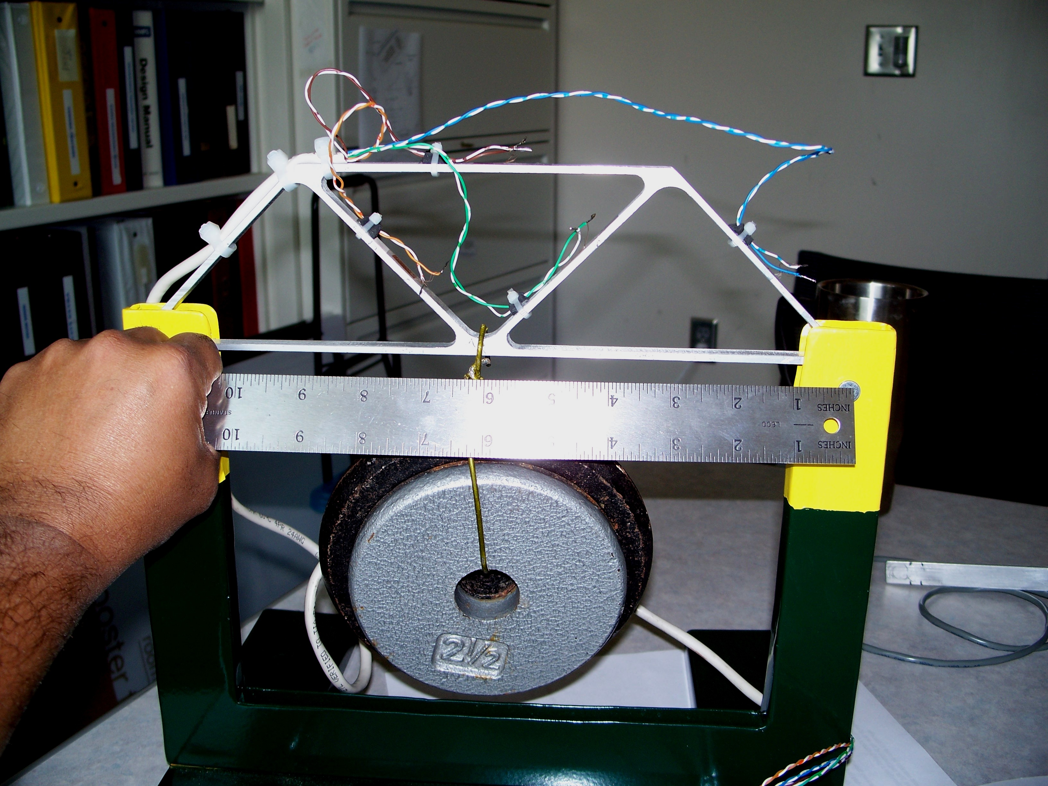
Figure 1. Loading the truss problem (Not to scale and not the actual aspect ratio)

